The Dutch Burghers in Sri Lanka: A People in Between the West and the East
By Prabhath de Silva

“We are a vanishing tribe in Sri Lanka. The first paternal ancestor of my father’s family who arrived in Sri Lanka in 1774 was Pieter Scharenguivel. He was a Quarter Master in the service of the United Dutch East India Company which ruled the maritime provinces of Sri Lanka from the middle of the 17th century to 1796. The Dutch Burgher identity and consciousness within the family I grew up was extremely significant. It played a role in the conversations, traditions, customs, food, perceptions and social interactions. During the British colonial rule, our community produced eminent surgeons, doctors, legal luminaries, judges, engineers, sportsmen, musicians , historians and artists etc.” , said Anne-Marie Scharenguivel 65, a management accountant and a member of Sri Lanka’s tiny Dutch Burgher community of less than 30000 people. The people known as ‘ Dutch Burghers ’ are descendants of the Europeans who arrived in Sri Lanka as servants of the United East India Company(Vereenigde Oostindische Compagnie- VOC)which ruled Sri Lanka’s maritime provinces from 1656 to 1796 or merchants and married native women or women who were children of mixed marriages between European men and native women.
Sri Lanka’s largest ethnic group is the Sinhalese, constituting 74.9% of the population of 21 million. The Sri Lankan Tamils, who live predominantly in the north and east of the island, are the largest ethnic minority group at 11.1% of Sri Lanka’s population. The Muslims are the third largest ethnic group at 9.3% of the population. Indian Tamils comprise 4.1% of Sri Lanka’s population. Smaller minority groups include the Malays, Burghers, Chetties (a originally trading community whose ancestors arrived from the southern parts of India) and the Veddahs -Sri Lanka’s indigenous people. Malays are descendants of Malay settlers brought by the Dutch colonial rulers.

The Dutch Connection with Sri Lanka
The Portuguese were the first European colonial power to arrive in Sri Lanka in 1505 when Sri Lanka had been divided into three kingdoms, namely the Kingdom of Kotte, Kingdom of Jaffna and the interior Kingdom of Kandy .Their presence in Sri Lanka’s maritime provinces between 1505 and 1656 CE, which began as an interaction of trade and commerce, later developed into a colonial rule in the maritime provinces( sans eastern coast from Trincomalee) downwards from 1597. Admiral Joris van Spilbergen (1568-1629), the Dutch circumnavigator, who commanded the fleet of ships’ Ram’, ‘Schaap’, and ‘Lam’ belonging to the Dutch company named Balthazar de Moucheron (a trading company that had been in existence before the establishment of the United East India Company -VOC in March 1602 ), landed in Batticaloa in Sri Lanka’s eastern coast on 31st May 1602, after a 12 month voyage at sea. Van Spilbergen met King Vimaladharmasuriya I, the King of Kandy (interior native kingdom of Sri Lanka), and negotiated the possibilities of trade in cinnamon and pepper and of providing military assistance to the King of Kandy to expel the Portuguese from the coastal regions of the Island. Van Spilbergen’s visit was the first Dutch visit to the Island. Spilbergen's was followed by the visits of the fleets of Dutch ships commanded by the Dutch navigator, Sebald de Weert in November 1602, Jacob Cornelisz in 1603and Marcellus de Boschouwer in 1612.
On 23 May, 1638, the Treaty of 1638 between the Kingdom of Kandy and the United East India Company was signed by King Rajasinghe II for the Kingdom of Kandy and Adam Westerwold and William Jacobsz Coster, a commander and vice commander of the Dutch Naval Forces representing the United East India Company (VOC) on 23 May, 1638 in Batticaloa. The treaty secured the terms under which the two nations would cooperate in defending the Kandyan Kingdom from the Portuguese. The writer vividly remembers visiting the Dutch State Archives in The Hague in 1985 accompanied by a Dutch Burgher lady friend (64 at that time) settled down in that city, to see one of the original copies of this treaty hand written in medieval Dutch. My Dutch Burgher lady friend whose father was a Ceylonese Dutch Burgher named Kriekenbeek and whose mother was a native Dutch lady, having left Ceylon ( Sri Lanka )in 1948 at the age of 24 and having lived in The Netherlands for almost 37 years, was able to translate the contents of the Treaty for me from Dutch to English. I can also remember the courtesy and kindness extended to me (then a 25 year old lawyer) by the Staff of the Dutch State Archives.

The key points of the 1638 Treaty were (a) the Dutch should provide the King of Kandy with military and naval assistance to drive the Portuguese from the Island ; (b) the Kandyan King should fully settle the military and naval expenditure incurred by the Dutch for onslaughts against the Portuguese by way of providing the Dutch with commodities such as cinnamon and pepper etc (c)the King of Kandy should grant the Dutch the monopoly of collecting spices and other commodities except elephants from the territories that constituted the Kingdom of Kandy; and (d) the Dutch should vacate the fortresses that would be captured from the Portuguese if the King would desire to take them over. Between 1640 and 1658 the Dutch completely expelled the Portuguese from the maritime provinces of Sri Lanka and ruled until 1796 when the British in turn replaced the Dutch and eventually took the whole island, including its holdout interior Kingdom of Kandy.The maritime provinces of Sri Lanka came under the rule of Dutch East India Company after its armies defeated the Portuguese in a series of battles between 1640 and 1658. When the Kandyan King, Rajasinghe II demanded the Dutch to vacate and hand over the captured Portuguese Fortresses and territories, the Dutch presented a bill of military and naval expenditure involved in the battles to oust the Portuguese and asked the King to settle the bill first. But Rajasinghe II who was unable to settle the bill ,would say that the Dutch had exaggerated the expenditure. The Dutch would maintain that they could hold the territories and fortresses captured from the Portuguese until the King Rajasinghe II and his successors would fully settle their bill of military and naval expenditure of onslaughts against the Portuguese. This was the legal foundation upon which the Dutch justified their occupation of the maritime provinces in the southern, western and northern coastal areas. Later they formulated another legal argument in their search for a legal basis for their rule in those regions. They argued that Rajasinghe’s Treaty of 1638 with them was a nullity with regard to the Kingdom of Kotte as King Don Jao Dharmapala had gifted it the King of Portugal in 1591 and the Portuguese had acquired the sovereignty of the Kingdom of Jaffna by conquest by war 1621,and as such Rajasinghe II, the King of Kandy had legal status (locus standi) to sign a treaty claiming the sovereignty over former territories of the Kingdom of Kotte (south western coastal areas of Sri Lanka)and the Kingdom of Jaffna( northern coastal areas). Afteoor a war between the Kingdom of Kandy and the forces of the United East India Company ,the dispute over the sovereignty of the maritime provinces was permanently settled by the Treaty of 1766, by which the King of Kandy conceded the territorial control of the western, southern, northern and eastern coastal areas to the Dutch. The maritime provinces were ruled by the Dutch East India Company from 1656 to 1796. During their period, a canal system was developed, a judicial system was introduced with the Roman-Dutch Law. The Roman-Dutch Law still remains to be the residuary common law in civil matters, though much of it has been replaced with English Law by statutes during the British rule. A number of Dutch words have become naturalized in the Sinhalese language . Among many such words are :Kamaraya in Sinhalese is derived from the Dutch word ‘Kamer’ for the room, Kanthoruwa in Sinhalese for office is derived from the Dutch word ‘Kantoor” for office, ‘ boodalaya’ in Sinhalese is derived from the Dutch word ‘Boedel’ for the estate of a deceased person, ‘Kakkussiya” in Sinhalese for the lavatory is derived from the Dutch word’ Kakhuis’. The British captured the maritime provinces of the Island in 1796 . Among other legacies of the Dutch rule are Dutch forts ad a few buildings preserved for posterity. The Dutch Burgher community in Sri Lanka is a living legacy of the Dutch period. When native feudal Chiefs ceded the sovereignty of the interior native Kandyan Kingdom to the British Empire by the Kandyan Convention of 1815, the whole Island came under the British rule. Sri Lanka gained independence from the British in1948.

Who are the Burghers and the Dutch Burghers?
The word 'Burgher' is derived from the Dutch word ‘Vrije Burgher ‘, meaning "free citizen" or "town's dweller". The Burghers in Sri Lanka are an Eurasian community of mixed origin, whose first paternal ancestors were European colonists [ mainly from Portugal, The Netherlands and the UK ] who had married native Sinhalese or Tamil women. The Portuguese men who opted to remain in Sri Lanka had married native Sinhalese or Tamil women because there were no Portuguese women in the Island. The children who were born in a marriage between the Portuguese colonists and native women in Portuguese colonies overseas were called Mesticos. The second and subsequent generations of Portuguese colonists who opted to remain in Sri Lanka preferred to marry the Mestico women and their second preference was the native women. The servants and soldiers of the Dutch East India who arrived in Sri Lanka were not only Dutch but belonged to other European nationalities too including German and French Protestants known as Huguenots ,Scandinavian and Italian. The servants and soldiers of the Dutch East India Company who opted to settle down in Sri Lanka during the Dutch Period, usually preferred to marry Mestico women and the marriages between them and native women were less frequent with the passage of time . The descendants of the European servants of the Dutch East India Company and Mestico women and native women ( Sinhalese and Tamil) became known as ‘Dutch Burghers’. In order to be considered as a Dutch Burgher, one’s father ought to have inherited an European family name from an European paternal ancestor who had come to Sri Lanka during the period Dutch East India Company ruled the maritime provinces of the Island. During the Dutch colonial period, the mother tongue or the lingua franca of the Dutch Burgher community in Sri Lanka was an Indo-Portuguese creole, though the Dutch Burghers later adopted English as their first language during the British colonial period.

Dutch Burghers during the British colonial rule in Sri Lanka
Although many portray British rule here as ‘exploitative’, of our country, they ignore the vast economic, social and educational developments that facilitated the transition from feudalism to capitalism and a parliamentary democracy. The contemporary progressive political trends in Britain with her social movements like utilitarianism, social, democratic and labour movements, too influenced colonial rule here. The British empire was an extension of British capitalism to the colonies including Ceylon. Lenin in his book “Colonialism: The Advanced Stage of Capitalism” presented a similar argument. Today, we beg for foreign investment. This is not a new phenomenon. During British colonial rule, British companies invested in the plantations and other sectors in Sri Lanka. These capitalists paid taxes to the British colonial government here on the profits they earned. Later parallel to the British and European capitalist class, an indigenous native entrepreneur class emerged . The colonial government managed the economy with its own tax revenue without borrowing from outside. The Dutch Burghers who were a sort of ‘people in between’ the west and the east were able to achieve eminent positions in the public service, medical profession, legal profession and judiciary during the British colonial period in Sri Lanka. They held a proportionately higher percentage of positions as clerks ,engineers, surveyors, journalists, locomotive engine drivers and railway guards in the public service. Their presence was significant in the employment of mercantile sector. It was the eminent Dutch Burghers like Charles Ambrose Lorensz were the pioneer constitutionalists who agitated for more liberal and democratic constitutional reforms during the 19th century British colonial Sri Lanka.

The Dutch Burghers in Post -Independence Sri Lanka
Sri Lanka gained independence from the British in 1948. Sri Lanka inherited from the British a democratic form of government based on the Westminster parliamentary model. At the time of Independence, Sinhalese majority constituted 66 % of Sri Lanka’s population and the Buddhists who were almost exclusively Sinhalese constituted 60% of the Sri Lanka’s population whilst the remaining 6% of the Sinhalese population were Christians. Sri Lanka’s ethno-religious and ethnic minorities ,at the time of independence constituted 34 % of Sri Lanka’s population. Sri Lanka’s first Prime Minister, D.S. Senanayake, a Sinhalese Buddhist was a pragmatic leader who did not want to upset the ethnic harmony prevalent at the time of independence. He and his political party the United National Party formed coalition governments with the major Tamil and Muslim parties and formed the cabinet of ministers representing Sri Lanka’s majority Sinhalese Buddhist community and other ethno-linguistic and religious minorities. He and his two immediate successors, Dudley Senanayake and Sir John Kotalawala after his death in 1952 refused to accede to the demands of the Sinhalese Buddhist nationalists for making Sinhalese the only official language replacing English, making Buddhism the State religion and for immediate take over of Christian denominational schools by the State. The Sinhalese Buddhist nationalists approached Solomon West Ridgway Dias Bandaranaike, who had broke away from D.S.Senanayake’s United National Party and had formed a new political party named Sri Lanka Freedom Party . Bandaranaike promised to implement all these demands of the Sinhalese Buddhist nationalists in the event his party would come to power at the next General Election. Bandaranaike was a Sinhalese born to a highly anglicized Christian aristocratic family. Educated at Oxford (1919-1925) ,Bandaranaike was a Barrister-at-Law and an eloquent speaker at the Oxford Union. A few years after his return to the Island from Oxford, Bandaranaike soon adopted the national dress, learned the Sinhalese language and began to tread on a path of communal politics based on Sinhalese Buddhist nationalism . In 1956, a coalition led by Bandaranaike’s on communal sentiments and slogans of the Sinhalese Buddhist nationalism and socialism, was elected to power and Bandaranaike became the Prime Minister . One of the first things his government hurriedly did was to enact an Official Language Act making Sinhalese, the only official language disregarding the Tamil and English , and the demand for making both Sinhalese and Tamil as official languages put forward by the Tamil political parties and Marxist political parties were rejected. The enactment of this piece of legislation deprived the English educated intelligentsia of Tamils ,Dutch Burghers and Sinhalese of public sector jobs unless they passed an examination to prove their proficiency in Sinhala language. Bandaranaike who began to experience the initial destructive consequences of his short sighted policies ,could not live long to witness the long term consequence of the whirlwind of communal tensions ,he set in motion through his unwise initiatives. In September 1959, Bandaranaike was assassinated by a Buddhist monk named Talduwe Somarama , a misguided instrument or a cat’s paw of a conspiracy of a group of Sinhalese Buddhists (led by a prominent Sinhalese Buddhist monk) who helped him come to power , but developed an enmity with him, when in power, Bandaranaike refused to help them form a shipping company. The enactment of Bandaranaike’s ‘Sinhala Only’ and the events that followed drastically changed the political landscape of Sri Lanka, with his Sri Lanka Freedom Party’s rival United National Party’s governments too pursuing the same policies when in power, resulting in communal riots of 1958,1977 and 1983 disturbances and tensions culminating in a 30-year civil war. pursued policies of her husband rigorously, and took over the denominational schools of which an overwhelming majority were Christian in 1961 to further appease the demands of the Sinhalese Buddhist nationalists withholding State grants and subsidies for such schools if they opted to remain private. As result only 51 Christian school out of hundreds of Christian schools could remain independent. Christians ,particularly Catholics considered the take over of their schools by the State a discriminatory blow. His widow elected to power again in 1970 with a two third majority in parliament severed the constitutional links with the British monarch as the ceremonial head of the state and abolished right to appeal the decisions of the Supreme Court of Sri Lanka to the Judicial Committee of the Privy Council of the United Kingdom. Her government enacted a Republican constitution granting Buddhism the foremost place in the Sri Lankan State, casting a constitutional duty upon the State to protect and foster Buddhism. Her government went further to perpetuate the Sinhala Only policy of her late husband by making Sinhala the only official language in the Sri Lankan State by incorporating provisions for such status in the new constitution of 1972. The enactment of Bandaranaike’s Sinhala Only Act and the events that followed drastically changed the political landscape of Sri Lanka, resulting in communal riots, disturbances and tensions culminating in a 30-year civil war. History has shown that issues of race, caste, religion, language and blind political affiliations have always been exploited by the leaders, and that these machinations have not originated from the ordinary people or peasants. Innocent peasants may be misled, misguided and mobilized by the leaders to achieve their narrow self–serving interests and ambitions by exploiting ethnicity, religion, caste and language in the South Asian political context. The Dutch Burghers ,having experienced anxieties and insecurities of their future prospects.

The Dutch Burghers, English language as Medium of Instruction in
Education & Lessons to Learn from Singapore

From the beginning of British colonial rule, primary and secondary education in the Sinhalese and Tamil medium was free from the kindergarten to the Senior School Certificate level (equivalent to today’s General Certificate of Education-Ordinary Level -in Grade 11) . But the English medium schools constituting about 10 -15 percent of the schools in Sri Lanka charged fees. The best children educated in the native languages, namely Sinhalese or Tamil, could reach was the teaching profession or becoming notaries, village headmen or ayurvedic physicians. The better jobs and access to tertiary education and the learned professions of Law and western medicine , judicial positions were only to those who attended the fee levying English medium schools. The official language of the government was English till 1956.
In 1928,the British government appointed a Royal Commission headed by Lord Donoughmore to inquire into further reforms to the constitutions to meet Sri Lankan aspirations. The Donoughmore Commission which consisted of progressive British politicians of the day, was fully convinced that the grant of universal adult franchise should be introduced in order to enable the ordinary peasants to elect representatives of their choice in order to speak on their behalf in the legislature for better health,educational and infra-structure facilities . The Donoughmore Commission’s recommendations were incorporated to a new constitution ,promulgated in 1931. By this constitution,whilst Sri Lanka was still under the British,universal adult franchise was granted to Sri Lankans to elect their own representatives to the legislature which became known as the State Council. In the newly elected legislature, a Board of Ministers were elected. The State Council appointed a Special Committee on Education headed by C.W.W .Kannangara which introduced the free education from the kindergarten to university level in 1942, also by a majority recommended that the medium of instruction in all schools should be the mother tongue in the primary classes. Having had the privilege of primary, secondary and tertiary education in English, he was one of the most persuasive advocates of native language education known as ‘ Swabhasha’ education. Sir Ivor Jennings records in his autobiography that the politicians’ views prevailed on this policy over the educationists’ opinions. Kannangara proposed that a child should receive education in his or her mother tongue and this triggered a debate in the Special Committee on what ought to be considered the mother tongue of a child. There were some Sinhalese and Tamil children whose mother tongue was English as that language was what was spoken in their homes. According to Sir Ivor, the politicians including Kannangara proposed a legal formula called ‘racial or ethnic mother tongue’. According to this formula, if the language of the progenitors of the ethnic group of the child’s father is Sinhalese, it should be irrefutably presumed that the Sinhalese language was the child’s mother tongue which should then be his or her medium of instruction in primary school even if his mother tongue was in fact English at home. This legal formula was proposed in respect of Tamil children too.
When it came to Muslims, Burghers and Malays, the Special Committee could not recommend applying this principle. If the legal formula of racial mother tongue was applied to these ethnic groups, the mother tongues of Muslim, Burgher and Malay children would respectively be Arabic, Portuguese/ Dutch/English and Malay. In order to overcome this difficulty, Muslims, Burghers and Malays were permitted to receive education in the English medium till the 1970s. Thereafter, the English medium education completely disappeared from the schools and the Dutch Burghers, Muslims and Mays were compelled to study either in Sinhala medium or Tamil medium in the national school system. The Kannangara Committees’ recommendations were adopted after Independence. Sinhalese and Tamil children in the English medium schools were required to study in the Sinhalese and Tamil mediums. The English medium schools were allowed to teach only the Muslim, Burgher and Malay children in the English medium. C.W.W. Kannangara was in fact the father of abolition of English medium education although S.W.R.D. Bandaranaike who was responsible for the enactment of Sinhala Only Act of 1956 is often wrongly blamed for Swabasha education. It was in the Bandaranaike’s tenure and his widow’s terms in power, the English medium was abolished in the secondary school level and in the tertiary level in universities except in Science, Engineering and Medicine courses.
Within two years of the Free Education Ordinance passed in 1942, as many as 44 Central Colleges were established throughout the country, mainly in the rural areas, with well equipped buildings, laboratories and hostels. These schools initially taught rural children in the English medium and some rural children entered the University of Ceylon from them in the early fifties. It certainly was a great revolution. However, the subsequent language policies adopted by successive governments deprived these rural children and others from established English medium schools the benefit of English medium education.
When Singapore gained independence in 1965, only 10 percent of the schools in that country used English as the medium of instruction whilst 80 per cent taught in Chinese and the rest in either Tamil or Malay. Lee Kuan Yew did not abolish English medium education but converted all non- English medium schools to English within a decade giving all Singaporean children, regardless of ethnicity, an equal opportunity to be taught in the English medium. He retained English as the working language of the country making English , Chinese, Tamil and Malay as official languages. Lee did this in a country where 80 percent of the population is ethnic Chinese. If Sri Lanka’s post Independence leaders had adopted this policy, we would not have had ethnic conflicts, tension, communal riots and a 30-year civil war immensely benefiting our development with an ethnically all inclusive public sector, private sector and governance in a unitary state. The Dutch Burghers and Tamils and educated Sinhalese would not have left the shores of Sri Lanka for more secure and greener pastures in the western countries.

Voices of the Dutch Burghers of Sri Lanka- Elderly and Young - in Today’s Social Milieu
In an evening, after the sun set, I paid a visit to Frederick van Buuren,88,a Dutch Burgher who lives with four Dashen pet dogs in small house at Mattegoda, a village in a suburb of Colombo. On my arrival, his four dogs started barking at me. Mr. van Buuren who welcomed me , said, “ They won’t bite” . He told his dogs kindly, “ Don’t bark. He is a friend. “ After their barking subsided , I started my conversation with Mr.van Buuren. Said Mr.van Buuren, “My first paternal Dutch ancestor was Willem Regenereus van Buuren. He married Anna Catherina Verwyk.The first European paternal ancestor of my mother's family ,who arrived in Sri Lanka in 1772 was Daniel Meerwald. His hometown was Neusol in Hungary. I was an automobile technician . I studied at Wesley College, Colombo. There were only two Dutch Burghers in my class, myself and another child with the Dutch family name Van Twest. I was born in Trincomalee on 23rd September 1932 when my father worked at the Public Works Department as an engineer in that town. My Dutch Burgher identity and consciousness within the family I grew up were very significant in the conversations, traditions, customs, perceptions ,moral,social ,religious political ideas. My father was very conservative, and he insisted that we should maintain our identity . At the Christmas table , we always had Dutch delicacies like Broeder and Poffertjes (Dutch Mini Pancakes) etc .We are a closed community. We moved only with the educated Sinhalese and Tamils. I was a Methodist. My wife ,Angela Jansz was a Catholic. A few months after my marriage ,I became Catholic by conviction.The Dutch Burghers have always politically been conservative and right wing. Only exception was Pieter Keuneman ,a Cambridge educated son of a Dutch Burgher Supreme Court Judge. Pieter Keuneman was the leader of country’s communist party.” When asked what the major cause for migration of thousands of Dutch Burghers to Australia, Canada and the United Kingdom, Mr.van Buuren opined: “ The exodus of Dutch Burghers to these western countries was due to Sinhalese language Only policy introduced by Prime Minister Bandaranaike in 1956 and the communal tensions that erupted in its aftermath.” Mr.van Buuren had migrated to Canada in 1966 with his Dutch Burgher wife Angela Jansz and three daughters. His wife passed away in 2006. Said Mr.van Buuren,” I obtained my duel citizenship in 2008. Since 2008, I live in Sri Lanka because I feel lonely in Canada but love warm climate and warmth of people here in Sri Lanka. I don't feel any discrimination in Sri Lanka on the basis of my Dutch Burgher identity. My Sinhalese neighbours treat me well”
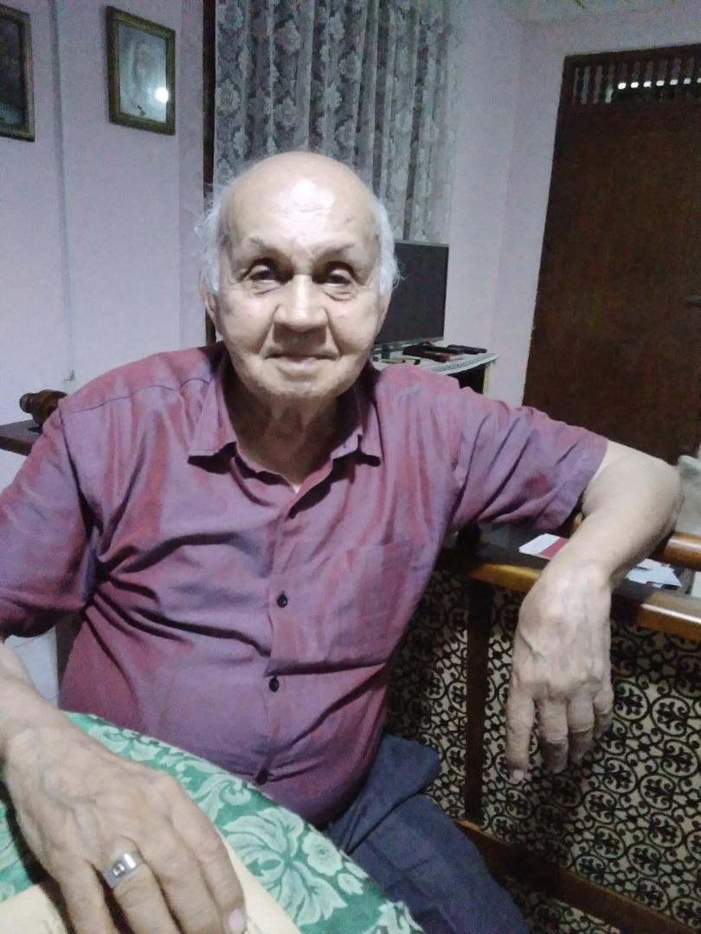
Frederick van Buuren
Mrs. Anne-Marie Scharenguivel,65, when asked what she thought, had been the major grievance of the Dutch Burgher community in post-independence Sri Lanka, said : “Our major grievance has always been our inability to be educated in our mother tongue English as the medium of instruction in the schools and the fact that all Govt departments function in Sinhala. I was forced to educate my sons in International schools at great cost due to this. Sinhala is a language, not spoken anywhere in the world! Thankfully the English stream is being reintroduced in schools but there are no proper teachers now competent to teach in English.” I asked Mrs. Scharenguivel “When thousands of Dutch Burghers have migrated to Australia, Canada and the UK, why did your parents and you opted to live in Sri Lanka? Mrs.Schrenguivel replied:
“ My father was well established here as Deputy Chief Waterworks Engineer in the Waterworks Dept of the CMC. He later became the Head of the Waterworks Dept ( which was changed to the Water Board later) and also acting Municipal Commissioner. I never wanted to leave either, and neither do my sons! . But now the future seems to be bleak for the Dutch Burgher community in particular and for the other ethnic minorities in Sri Lanka. This is the first time in our lives my sons and I have felt like immigrating “
Mrs.Scharenguivel, a cradle Catholic ,is an old girl of St.Bridget’s Convent, lives in Dehiwela, a suburb of Colombo.
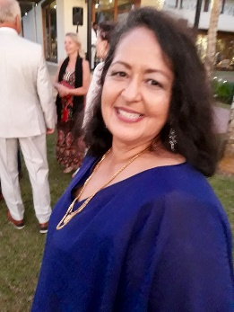
Anne-Marie Scharenguivel
Mrs.Doreen van der Hoeven, 64, is a mother of two sons. She is a Dutch Burgher who lives in Kalutara , a coastal town 40 km south of Colombo. “My father was a train guard in the Ceylon Government Railway. In those days, A lot of Dutch Burgher men worked in the Ceylon Government Railway as engine drivers and train guards. “ ,said Mrs. van der Hoeven. She added, “ My mother who is 94 years old is a Scharenguivel. My parents were Dutch Burghers. I was educated at Methodist College, Colombo. We are Methodists by religion. I am the only child in my family. I became aware of my Dutch Burgher identity when I was a child. I used to ask my parents why we were different from others in language, family name and complexion. Then my parents would tell me about my Dutch Burgher ancestry I am a nurse by profession. I still remember having Dutch Broedher on our family Christmas table in my childhood . Most of my Dutch Burgher cousins ,relatives and friends have migrated to Canada Australia and the United Kingdom. Our community was affected by the Sinhalese Only language policy which did away with English language in the schools as a medium of instruction and as an official language . That was the reason for Dutch Burgher migration to Australia, Canada and the United Kingdom.”.
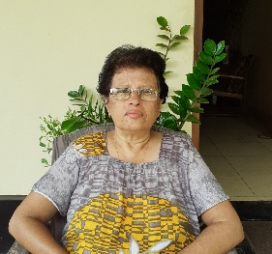
Doreen van der Hoeven
Voices of the Young
Miss Andriana Melder, 23, is a Dutch Burgher young lady. She holds a Bachelor of Laws degree from the University of London. She is now studying for the examinations of the Bar. Adriana is a Catholic and is an old pupil of Holy Family Convent, Colombo 4. She lives in Nugegoda, a town in the suburbs of Colombo.

Andriana Melder
“ My first paternal Dutch ancestor was Reverend Willem Melder who had come from Holland to serve as a minister of the Dutch Reformed Church of Sri Lanka (founded by the Dutch in 1642 and now known as Christian Reformed Church of Sri Lanka). He had married Madalena Petronella Perera at the Wolvendaal Church in Colombo. The initial ancestors of the Melder clan in Sri Lanka worked as Dutch Civil servants and the later as planters and spice traders. At one point in my paternal family tree, my ancestors had become Catholic leaving their Protestant faith for some reasons, ” said Andriana Melder.
Speaking of the significance of her Dutch Burgher identity ,culture, religious and moral values , Andriana opined: “ My Dutch Burgher identity played a pivotal role in my upbringing. My father was very proud of this identity and his heritage. He would often point out old buildings and vast portions of land In Melder Place and Pietersz Place in Nugegoda (which has now mostly been sold off or occupied by various individuals due to the risen rates of migration of our relatives to Australia,New Zealand ,Canada and the United Kingdom). Claiming that these used to once belong to our ancestors and the fond memories he had as a child playing cricket in the vast fields,fishing and even hunting with my Late grandfather with his double barrel gun slung over his shoulder. We were brought up to value our culture, the elders set the example by maintaining records and journals for the younger generations to refer. Many articles too have been preserved to generate knowledge of the yesteryears of the Melder clan. My late paternal grandmother and my grand aunts and uncles on my father’s side used to relate stories from the good old days in the times of Ceylon, about the great big dances and parties they used to throw on various occasions. The carefree, happy go lucky attitude passed down through the generations is visible even in the youth in my family today. There is no pressure as to marriage, sense of fashion or lifestyle. The freedom to make ones own choices have been ingrained even in our young minds. Learning to play an instrument, singing and dancing is an essential aspect of our life. This has resulted in many burgher youth becoming confident and passionate about the arts. My extended family is very religiously and racially inclusive as many of my relatives have inter married into various faiths and races. Education takes centre stage in our family as most of my ancestors are welleducated and rounded individuals who have achieved much in their respective professions. The general perception among the other ethnic communities that most Dutch burgher youth lack morals and religious affiliation is profoundly untrue, many of us are staunch practicing Christian( Catholics and Protestant ) whose morals have been intertwined with religion. The Dutch Burgher families are a closely knit communit,y and they value that familial aspect in their relationship with individuals.
When asked what in her opinion, have been the legitimate grievances of the Dutch Burgher community since the independence, Andriana said, “ It is the lack of recognition even as a minority. The language and cultural barriers are pertinent to date as the lack of an inclusive system for all races is still present. The Dutch Burgher community as contributed much in terms of construction, law and the judicial system, religion,hybrid culture and cuisines. They are a unique community underestimated and those unique qualities of theirs overshadowed by somewhat of an assimilation of cultures and traditions.
The post 1956 migration of many Burgher families from the island was a result of them not
seeing a future for their children in the new Ceylon. Most migrated to Australia because
Australians had a life style closer to theirs. Others moved to Canada, the UK and New Zealand.
Many Burgher migrants held very senior positions in the Mercantile, Banking, Medical, Academic
and Public sectors. Still, most of them even in diaspora still consider the island known to them as
Ceylon, as their beloved home that nurtured them as a community for about four centuries.
We decided to remain in SL as my father was well established in his profession and because
of my grandparents from both sides of the family.I would like to leave SL once I complete my studies as many of my friends and relatives are already abroad and seeing how their lifestyle seem much better and their future more promising,I too would like to migrate one day.”

Speaking of the future of the Dutch Burgher Community, Andriana said: “ The Dutch Burgher community is dwindling at present with the vast increase in migration and inter marriages taking place. Further, with racist ideologies rising once more, the future for the minorities seem bleak.

My last interview for this article was with a young Dutch Burgher gentleman named Fabian Schokman,24. Fabian is a graduate in Theology now reading for a Bachelor of Laws degree of the University of London. A Catholic by faith, Fabian is very outspoken. “ My first paternal Dutch ancestor was Jan Arentsz Schokman who had come to Sri Lanka from Amsterdam in 1697,and he was a Ship Carpenter’, said Fabian. When asked how significant was his Dutch Burgher identity and consciousness within the family you grew up in the conversations, traditions, customs, perceptions ,moral,social ,religious and political ideas , Fabian said: “It had a strong bearing on my upbringing, especially in terms of perceptions and to a greater level, openness to liberal ideologies. Tradition has always being a closely guarded and cherished part of my upbringing, especially by the elderly generation growing up. It varies starkly across a spectrum. Identity is a matter of self perception and this self perception would vary widely among a single family, multiple families that comprise of a unit and most certainly in the community in general. As I mentioned, there is and has always being the ultra-conservative and ultra-liberal ends of the community and every shade in-between. As with the other questions, this must be analyzed from among the spectrum. Of course the more traditional Dutch Burgher families are undeniably facing the extinction of cultural identity as assimilation means more and more of the individualistic aspects of the community are fading to give way to a more conforming cultural identity and the days of a monolinguistic starkly distinct community are fast fading, yet in a more general perspective, the community in my opinion, because of its considerably minute size faces a number of issues stemming from lack of political representation. I believe that one's identity is and should be a part of everyday life. As a lesser minority, even in the context of school and community in general, I have found the Dutch Burgher community to be rather close-knit, not least on account of the vast inter-connection between them, but also on account of the specificity that separates us. That being said, this identity is in no way antithetical to centrist Sri Lankan values.

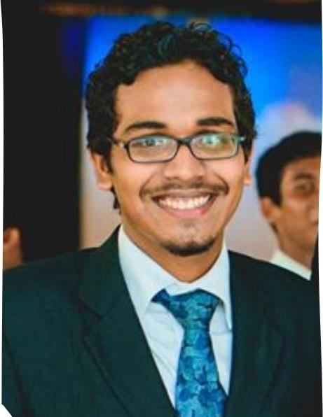
Fabian Schokman
Fabian seems to think that the future for the Dutch Burgher community in Sri Lanka seems less bleak than what other members of his community believe . Fabian opined:
“The Dutch Burgher community has always had a spirit of endurance and survival imbued deep within itself and as a result the community will survive, perhaps more intact than other lesser non-monogamous minorities. At present the community has found vast roles of prominence in the private sector and I particularly don't see a return to the age of civil service dominance, there is also a deep sense of pride and cultural revival in the younger generation and this does make the future seem less bleak, however in comparison to the larger minorities with considerable communal and political representation, a stable lineal prediction is difficult to project.”

